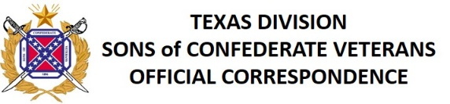

Chaplain's Connection
August 2017

1 Corinthians 16:13 - Remain alert. Keep standing firm in your faith. Keep on being courageous and strong.

Hundreds of our members and friends gathered together at the Travis Park Confederate Cenotaph in San Antonio at 2:00 PM on Saturday, August 12 to join with the United Daughters of the Confederacy and Texas Freedom Force to help save the monument. I share with you my closing comments and Benediction.

"As Chaplain of the Texas Division of Sons of Confederate Veterans, representing thousands of our members all across this great state of Texas, and as a member of General John Bell Hood's Texas Brigade, and the Lawrence Sullivan "Sul" Ross Chapter of Military Order of Stars & Bars, and my wife a member of Albert Sidney Johnston Chapter of United Daughters of the Confederacy, I am honored to be here today in front of this beautiful and historic Cenotaph honoring these and all of our Texas Heroes. (shouts from the crowd of Camps names after our Texas heroes)

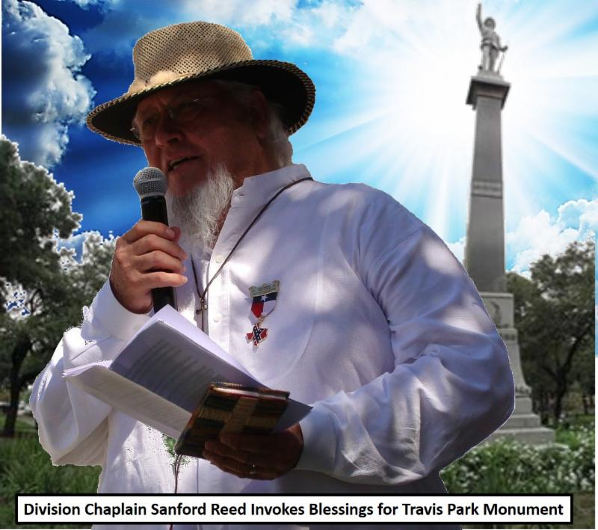

From the book The True History of the War for Southern Independence, we are reminded that "There are two kinds of Americans. There are those who want to be left alone to pursue their destiny, restrained only by tradition and religion; and there are those whose identity revolves around compelling others to submit to their own manufactured vision of the good Society."

I have chosen Psalm 1 as the centerpiece for this ceremony today because this is a Psalm of instruction concerning good and evil, setting before us life and death, the blessing and the curse, that we may take the right way which leads to happiness and avoid that which will certainly end in our misery and ruin.

The different character and condition of godly people and wicked people, those that serve God and those that serve him not, is here plainly stated in a few words; so that every man, if he will be faithful to himself, may here see his own face and then read his own future.

This psalm shows us, (1) The holiness and happiness of a godly person . (2) The sinfulness and misery of the wicked, and (3) The ground and reason of both.

No scripture could better highlight the difference between those of us who choose to protect our Texas heritage and history, and those who work to destroy it.

READING from KJV - Psalm 1:
"1 Blessed is the man that walketh not in the counsel of the ungodly, nor standeth in the way of sinners, nor sitteth in the seat of the scornful.
2 But his delight is in the law of the Lord; and in his law doth he meditate day and night.
3 And he shall be like a tree planted by the rivers of water, that bringeth forth his fruit in his season; his leaf also shall not wither; and whatsoever he doeth shall prosper.
4 The ungodly are not so: but are like the chaff which the wind driveth away.
5 Therefore the ungodly shall not stand in the judgment, nor sinners in the congregation of the righteous.
6 For the Lord knoweth the way of the righteous: but the way of the ungodly shall perish."

In closing, please join me in the RESPONSIVE PRAYER - Let us pray:

Dear Heavenly Father, we pray That we may all live in peace and achieve unity in honoring our ancestors, those buried here and those in unknown graves elsewhere. This is our Prayer :
That all may be faithful servants, leading others to an understanding of the true history of our country and the South: This is our Prayer

That the leaders of the world, our nation and this city may govern with justice and mercy: This is our Prayer

That all our work may be done for the common good; that it be done in safety; and that all may be spared the travails which destroys fullness of life: This is our Prayer

That those who work on frontiers of truth who enrich our lives with beauty and joy may be free to follow their vocations: This is our Prayer

That those who suffer poverty, pain, loneliness or grief may be healed and comforted; that those who are oppressed or persecuted may be strengthened and delivered: This is our Prayer

That our dear ancestors whom we have known and loved who have died in the faith may be a glorious memory to us and a source of renewed fellowship with all the saints: This is our Prayer, in Jesus name. Amen

BENEDICTION: Go forth in Peace and Safety, and may the grace of the Lord Jesus Christ, and the love of God, and the communion of the Holy Spirit be with you all. AMEN

Several Camps have requested a brief ceremony to use to honor and protect a monument, cenotaph, grave, statue, or memorial. We must always strive to add dignity and honor to any ceremony. This approach is very effective in promoting our Cause and elevating the Sons of Confederate Veterans above the base and degrading shouts of our opponents.

May God Bless you,
Sanford Reed
Chaplain
Texas Division, SCV
sanfordreed@gmail.com

---------------------------------------
This email is Official Correspondence of the Texas Division, SCV. It is intended for the dissemination of important information to Texas Division Compatriots. It is NOT intended to be used as a forum or blog. If you have a concern, comment or suggestion, please convey them directly to the originator listed above via a private, personal email.
---------------------------------------
Best regards,
Lee R Lance
3rd Lt. Commander
Texas Division
Sons of Confederate Veterans

